Complete tasks, related to training 37:

Locate css and xpath selectors for following elements in RMSys (2 variants – css and xpath – for each, do NOT add them to project, just create word document with these locators):

**Login page:**

1. Username input

Xpath = //input[@id=’Username’]

CSS = input[id=Username]

1. Password input

Xpath = //input[@id='Password']

CSS =input[id=Password]

1. Remember me label

Xpath = //label[@for='Remember']

CSS = label[for='Remember']

1. Remember me input

Xpath = //input[@class='custom-chBox']

CSS = input[class='custom-chBox']

1. Login button

Xpath = //button[@id='SubmitButton']

CSS = button[id='SubmitButton']

**Home page:**

1. Sign out link

Xpath = //a[@title='Sign out']

CSS = a[title='Sign out']

1. Selector, which grabs all links to offices (see screenshot 1)

Xpath = //ol[@class='officeShortInfo zebraStyle']//a

CSS = ol[class='officeShortInfo zebraStyle'] a

1. Link to Chapaeva 118 office

Xpath = //a[@href='#Office-Chapaeva 118']

CSS = a[href='#Office-Chapaeva 118']

1. Link to Lunch Voting

Xpath = //a[@href='https://lunchvoting.issoft.by/']

CSS = a[href='https://lunchvoting.issoft.by/']

**Vacation page -> Create Vacation tab:**

1. Information span for Notification To

Xpath = //div[@id='thirdContainer']//span[@class='question']

CSS = div[id='thirdContainer'] span[class='question']

1. Information span for Notification CC

Xpath = //div[@id='fourthContainer']//span[@class='question']

CSS = div[id='fourthContainer'] span[class='question']

**Company page:**

1. Selector, which grabs all containers for companies (see screenshot 2)

Xpath = //ul[@id='list-items']/*

CSS = ul[id='list-items']>li

1. Selector for Contact tab, which will be suited for all companies (see screenshot 3 and 4)

Xpath = //a[contains(@href,'/CompanyContact/ShowContacts?companyID=')]

CSS = a[href^='/CompanyContact/ShowContacts?companyID']

**Screenshot 1 (for ‘g’):**

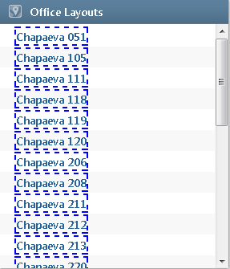

**Screenshot 2 (for ‘l’):**

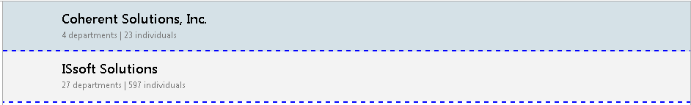

**Screenshot 3 (for ‘m’):**

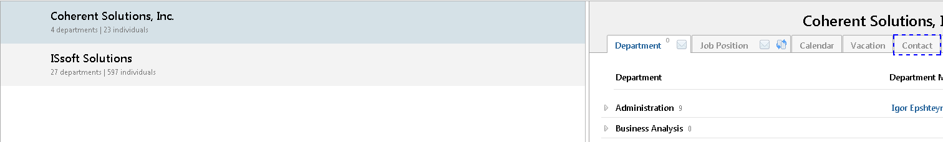

**Screenshot 4 (for ‘m’):**

